EXP. NO: 16
SIMULATION AND ANALYSIS OF UNIFORM AND NON-UNIFORM QUANTIZATION USING MATLAB
Objectives
i) To implement and analyze uniform and non-uniform quantization techniques for an analog
signal using MATLAB by converting the continuous-amplitude signal into discrete
quantization levels.
PROGRAMMING CODE:
clc;
clear;
close all;

% Parameters
Am = 1; % Signal amplitude
fm = 5; % Signal frequency in Hz
fs = 1000; % Sampling frequency in Hz
T = 1; % Signal duration in seconds
n = 3; % Number of quantization bits
L = 2^n; % Number of quantization levels

% Generate Analog Signal
t = 0:1/fs:T;
x = Am*sin(2*pi*fm*t);

% ---------------- UNIFORM QUANTIZATION ----------------

xmin = -Am;
xmax = Am;
Delta = (xmax-xmin)/L; % Quantization step size

% Uniform quantization
x_uniform = xmin + Delta/2 + ...
Delta*floor((x-xmin)/Delta);

% Limit output to maximum quantization level
x_uniform(x_uniform > xmax-Delta/2) = xmax-Delta/2;

% ---------------- NON-UNIFORM QUANTIZATION ----------------

% Mu-law compression parameter
mu = 255;

% Normalize input signal
x_norm = x/Am;

% Mu-law compression
x_compressed = sign(x_norm).* ...
log(1+mu*abs(x_norm))/log(1+mu);

% Quantize compressed signal uniformly
Delta_mu = 2/L;
xq_compressed = -1 + Delta_mu/2 + ...
Delta_mu*floor((x_compressed+1)/Delta_mu);

% Limit quantized values
xq_compressed(xq_compressed > 1-Delta_mu/2) = ...
1-Delta_mu/2;

% Expand the quantized signal
x_nonuniform = sign(xq_compressed).* ...
((1+mu).^abs(xq_compressed)-1)/mu;

% Restore original amplitude
x_nonuniform = Am*x_nonuniform;

% ---------------- PLOTTING ----------------

figure;

subplot(3,1,1);
plot(t,x,'b','LineWidth',1.5);
title('Original Analog Signal');
xlabel('Time (s)');
ylabel('Amplitude');
grid on;

subplot(3,1,2);
stairs(t,x_uniform,'r','LineWidth',1.2);
hold on;
plot(t,x,'b--');
title('Uniform Quantization');
xlabel('Time (s)');
ylabel('Amplitude');
legend('Quantized Signal','Original Signal');
grid on;

subplot(3,1,3);
stairs(t,x_nonuniform,'m','LineWidth',1.2);
hold on;
plot(t,x,'b--');
title('Non-Uniform Quantization using Mu-Law');
xlabel('Time (s)');
ylabel('Amplitude');
legend('Quantized Signal','Original Signal');
grid on;

% ---------------- ERROR CALCULATION ----------------

error_uniform = x-x_uniform;
error_nonuniform = x-x_nonuniform;

MSE_uniform = mean(error_uniform.^2);
MSE_nonuniform = mean(error_nonuniform.^2);

fprintf('Number of Bits = %d\n',n);
fprintf('Number of Quantization Levels = %d\n',L);
fprintf('Uniform Quantization Step Size = %.4f\n',Delta);
fprintf('Uniform Quantization MSE = %.6f\n',MSE_uniform);
fprintf('Non-Uniform Quantization MSE = %.6f\n',MSE_nonuniform);
OUTPUT:
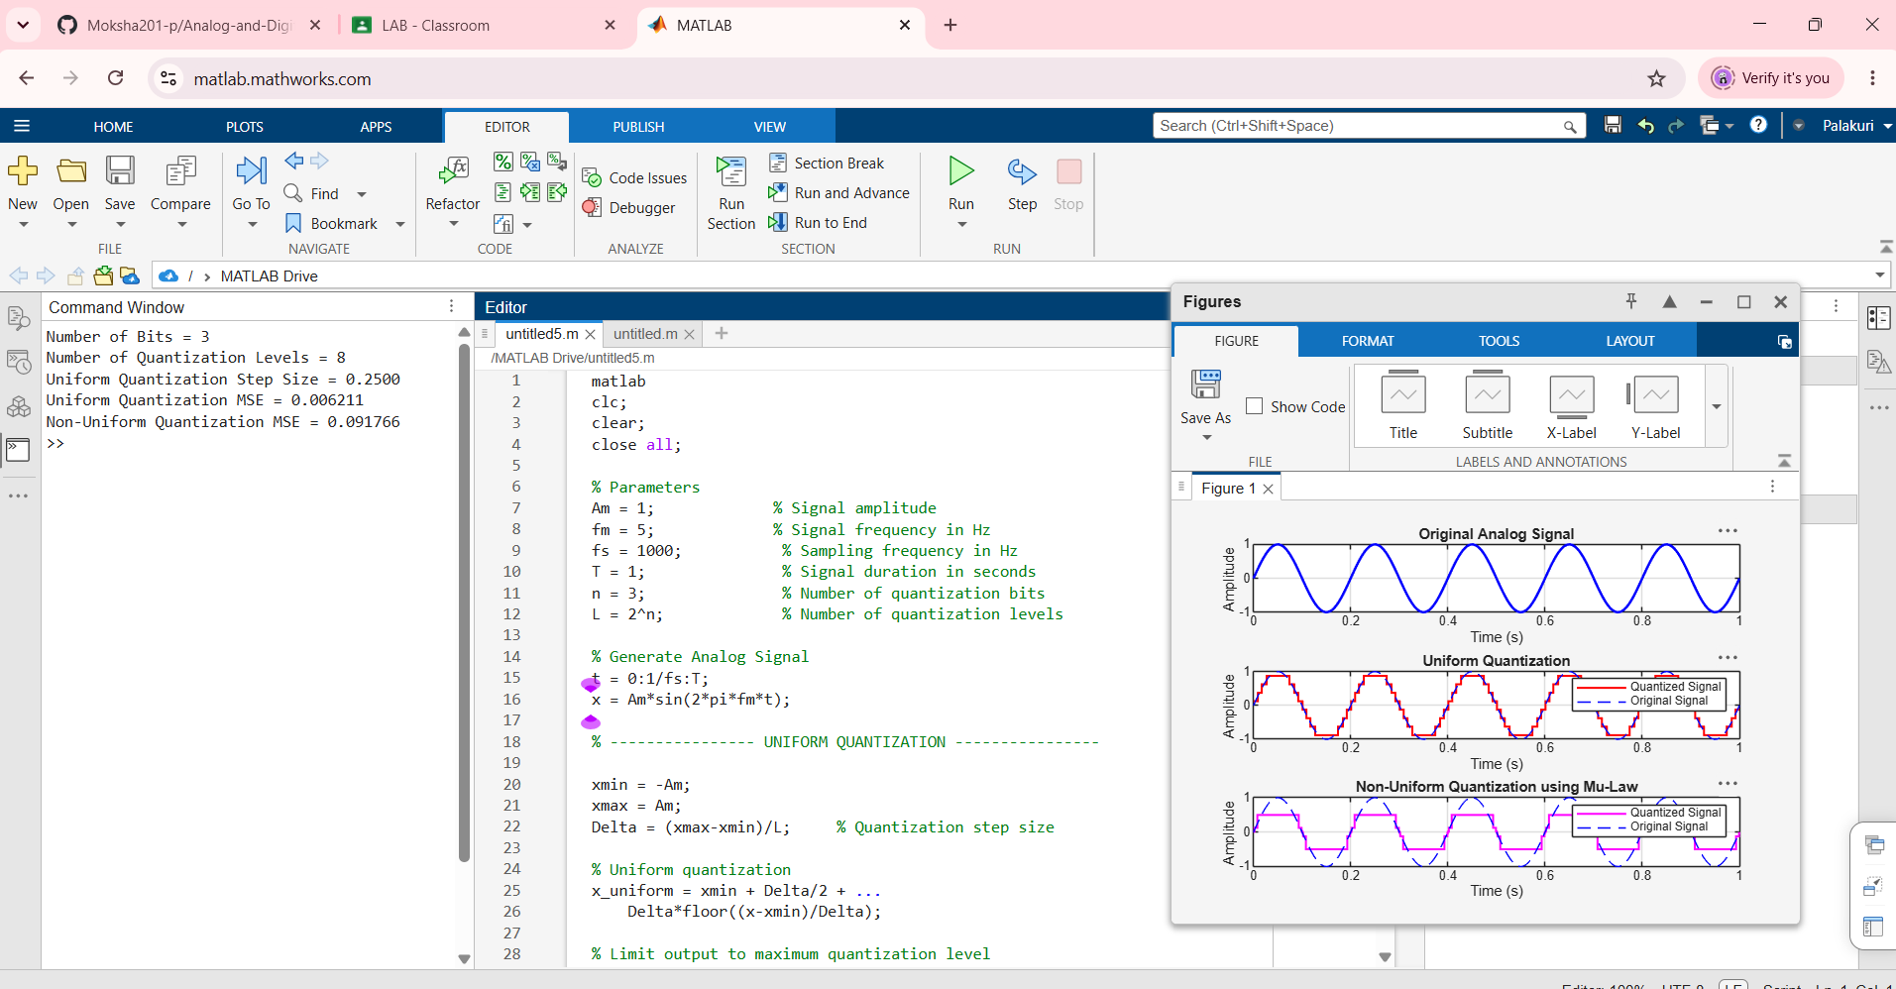
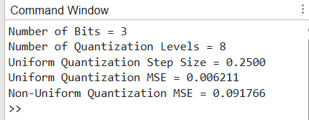

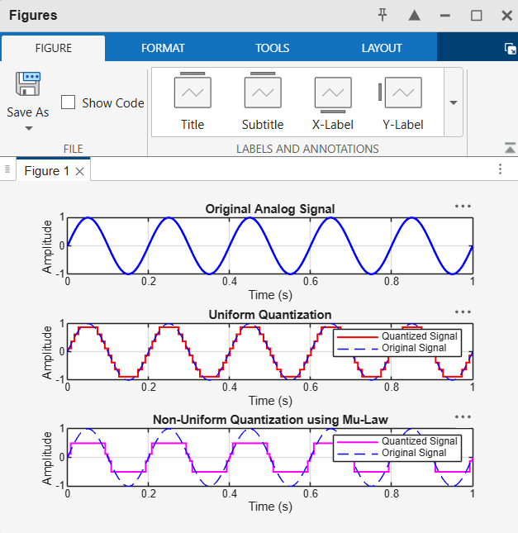

OBJECTIVE:
ii) To compare the performance of uniform and non-uniform quantization by analyzing their
quantized waveforms and quantization errors, and evaluate their effectiveness in representing
signals with different amplitude variations.
PROGRAMMING CODE:
clc;
clear;
close all;

% EXPERIMENT NO: 16
% Comparison of Uniform and Non-Uniform Quantization

% Signal Parameters
Am = 1; % Amplitude of the signal
fm = 5; % Message frequency in Hz
fs = 1000; % Sampling frequency
T = 1; % Duration in seconds
n = 3; % Number of bits
L = 2^n; % Number of quantization levels

% Generate Input Signal
t = 0:1/fs:T;
x = Am*sin(2*pi*fm*t);

% -------------------------------
% 1. UNIFORM QUANTIZATION
% -------------------------------

xmin = -Am;
xmax = Am;

Delta = (xmax-xmin)/L;

x_uniform = xmin + Delta/2 + ...
Delta*floor((x-xmin)/Delta);

x_uniform(x_uniform > xmax-Delta/2) = xmax-Delta/2;

% Uniform Quantization Error
error_uniform = x-x_uniform;

% -------------------------------
% 2. NON-UNIFORM QUANTIZATION
% Using Mu-Law Companding
% -------------------------------

mu = 255;

% Normalize the input signal
x_norm = x/Am;

% Mu-law compression
x_compressed = sign(x_norm).* ...
log(1+mu*abs(x_norm))/log(1+mu);

% Quantize the compressed signal
Delta_mu = 2/L;

xq_compressed = -1 + Delta_mu/2 + ...
Delta_mu*floor((x_compressed+1)/Delta_mu);

xq_compressed(xq_compressed > 1-Delta_mu/2) = ...
1-Delta_mu/2;

% Expand the quantized signal
x_nonuniform = sign(xq_compressed).* ...
((1+mu).^abs(xq_compressed)-1)/mu;

x_nonuniform = Am*x_nonuniform;

% Non-Uniform Quantization Error
error_nonuniform = x-x_nonuniform;

% -------------------------------
% 3. CALCULATE PERFORMANCE
% -------------------------------

MSE_uniform = mean(error_uniform.^2);
MSE_nonuniform = mean(error_nonuniform.^2);

fprintf('Number of Quantization Levels = %d\n', L);
fprintf('Uniform Quantization Step Size = %.4f\n', Delta);
fprintf('Uniform Quantization MSE = %.6f\n', MSE_uniform);
fprintf('Non-Uniform Quantization MSE = %.6f\n', MSE_nonuniform);

% -------------------------------
% 4. PLOT QUANTIZED WAVEFORMS
% -------------------------------

figure;

subplot(3,1,1);
plot(t,x,'b','LineWidth',1.5);
title('Original Analog Signal');
xlabel('Time (seconds)');
ylabel('Amplitude');
grid on;

subplot(3,1,2);
stairs(t,x_uniform,'r','LineWidth',1.2);
hold on;
plot(t,x,'b--');
title('Uniform Quantization');
xlabel('Time (seconds)');
ylabel('Amplitude');
legend('Quantized Signal','Original Signal');
grid on;

subplot(3,1,3);
stairs(t,x_nonuniform,'m','LineWidth',1.2);
hold on;
plot(t,x,'b--');
title('Non-Uniform Quantization Using Mu-Law');
xlabel('Time (seconds)');
ylabel('Amplitude');
legend('Quantized Signal','Original Signal');
grid on;

% -------------------------------
% 5. PLOT QUANTIZATION ERRORS
% -------------------------------

figure;

subplot(2,1,1);
plot(t,error_uniform,'r','LineWidth',1.2);
title('Uniform Quantization Error');
xlabel('Time (seconds)');
ylabel('Error');
grid on;

subplot(2,1,2);
plot(t,error_nonuniform,'m','LineWidth',1.2);
title('Non-Uniform Quantization Error');
xlabel('Time (seconds)');
ylabel('Error');
grid on;

% -------------------------------
% 6. COMPARE MSE
% -------------------------------

figure;

bar([MSE_uniform MSE_nonuniform]);
set(gca,'XTickLabel',{'Uniform','Non-Uniform'});
title('Mean Square Error Comparison');
ylabel('Mean Square Error (MSE)');
grid on;
OUTPUT:
